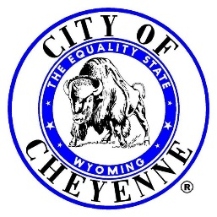
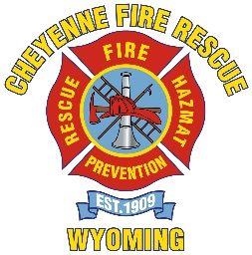
Fire Prevention Bureau

415 W. 18th Street
Cheyenne, WY 82001
307-637-6311
www.cheyennecity.org cfrprevention@cheyennecity.org

The City of Cheyenne Fire Department
PUBLIC NOTICE
Notice of Meeting
The Intergovernmental Fire Code Board of Appeals (IFC BOA) will hold its next meeting on:
Date: Wednesday, March 12th, 2024, Time: 11:00 AM Location: Cheyenne Fire Department Administrative Office
This meeting will be held in person and is open to the public.
Agenda:
- Review of recent fire code changes.
- General discussion.
This meeting will be held as scheduled even if there are no pending issues before the Board.
All interested parties are welcome to attend.

